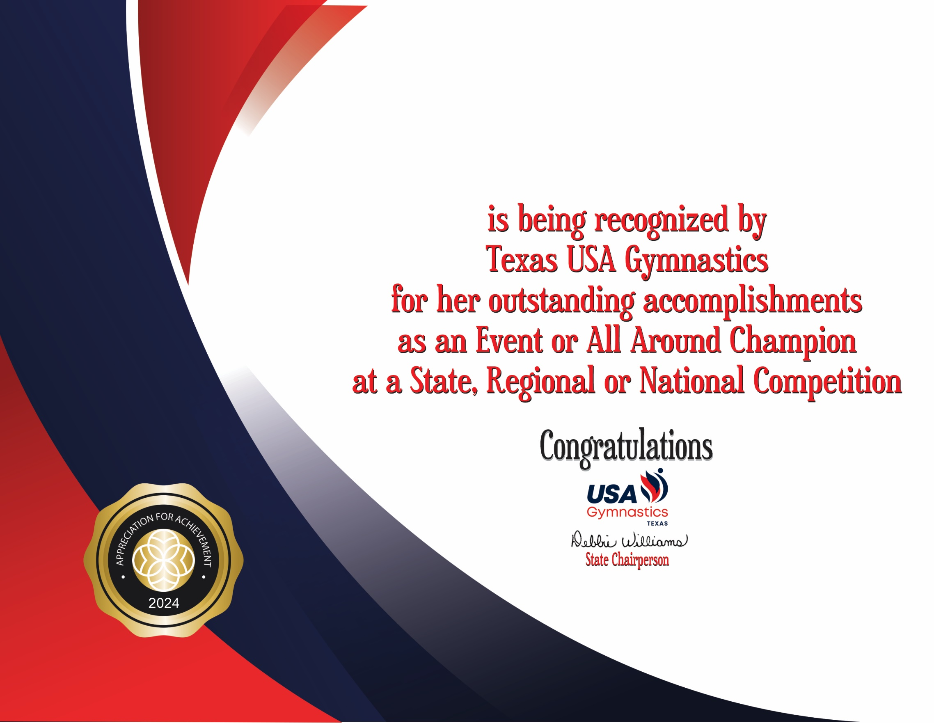

Georgia Ann Abbott

Emerson Acuff

Karina Victoria Aguirre Cox

Ziva Aiken

Kennedy Alkire

Taylor Allen

Addison Anders

Olivia Anene

Gianna Arthur

Hannah Arujo

Symone Aubrey

Bria Avila

Kathy Balsomi

Khloe Battle

Payton Beck

Katelyn Becker

Abbey Beckwell

Julia Beltreschi

Hadley Bird

Reese Bishop

Shaina Bissell

Michelle Bonzagni

Aria Borromeo

Autumn Boswell

Violet Bouldin

Kylie Bourgeois

Ansyn Bracken

Maegan Bradway

Isabel Rios Bray

Emily Brunner

Alexis Bullitt

Peyton Bunck

Amira Burgin

Christina Burmeister

Haleigh Burton

Grace Bymaster

Ayva Caicedo

Sofía Campos

Taylor Carmack

Sophia Carrasco

Arden Casco

Evie Case

Kaley Casey

Maci Caudle

Evangeline Chala

Felicity Chambers

Inara Chapman

Caroline Chen

Michelle Chen

Alicia Chen

Aubrie Cheng

Katelyn Christman

Jennifer Cidrian

Tenley Clark

Julia Coleman

Taylor Copeland

Sofia Cordero

Isabella Cox

Aubrey Craft

Samantha Cranfill

Heaven Cravens

Jurzie Blu Cromartie

Tabitha Cruz

Dorothy Cummins

Atheena Daba

Blair Davidson

Emma Day

Madigan Day

Raelyn DeGroot

Ellyana Dehoyos

Leighton Didier

Hannyn Didier

Colette Dieterlen

Sarah Dooley

Brooklyn Drewery

Samantha Driver

Ava Duchesne

Madelyn Eagle

Amelia Earley

Whitley Eppes

Charlotte Escamilla

Emmy Eversman

Emily Fantuzzo

Haylee Finley

Elizabeth Forsythe

Whitney Forsythe

Lilly Galicia

Kaia Gall

Angelica Garza

Addison Gavin

Avery George

Nevaeh Geter

Kyleigh Ghanbari

Georgia May Giamona

Breanna Gillean

Kaydence Gillis

Layla Gilpin

Julia Alyse Glasco

Bella Godoy

Kaeleigh Goins

Kyla Golden

Emma Gonzales

Cassidy Gonzales

Leah Gonzalez

Leilani Goodman

Sophia Gravel

Avery Griffin

Hannah Griffin

Katie Griffith

Kirana Griffith

Ellie Grigsby

Katelyn Grimal

Keayana Haase

Leah Haddis

Rafaella Haeve

Gracin Hamilton

Keoni Hardeman

Amiyah Harrison

Jaislyn Heater

Kaylee Hendrix

Sophia Hernandez

Charlotte Herrscher

Anderson Hicks

Alexandra Hollander

Kerigan House

Yina Huang

Ella Hufsey

Gentry Hughes

Maddy Jacobs

Yadira Jardon

Paige Jarvis

Savannah Johnson

Amelia Kacsmaryk

Cora Kilpatrick

Brooklyn Klauser

Caroline Kraatz

Julianna Kraatz

Makena Kyle

Chadré Labuschagne

Reese Landry

Vallory Lane

Dakota Larimer

Colby Leach

Seraiah Leake

Brooklyn LeCompte

Bailey Leonard

Nydalynn Lindsey

Alyssa Livingston

Sydney Lohr

Micayla Madden

Chloe Mankarious

Kaitlyn Martineau

Kyra Martinez

Abigail McGinnis

Landry Mead

Jessica Meyers

Savannah Mmeje

Harper Moore

Londyn Moore

Mila Morris

Palmer Morris

Scarlett Munoz

Helen Naylor

Mackenzie Neumann

Brooklyn Newbro

Addyson Noelanders

Cadyn Nyland

Eden Oldeen

Cadence Oliver

Jamison Owens

Reagan Paben

Catarina Palladio

Ally Palmos

Lillian Paniagua

Kaitlyn Parbs

Reagan Parrish

Adalyn Patel

Anaya Patel

Valerie Perdomo

Olivia Perez

Samantha Pirela

Star Poncio

Riley Pope

Isabella Porto

Ella Potter

Alessandra Ramirez

Reese Ray

Ainsley Reed

Danielle Reeves

Graysen Rhodes

Alexis Roberts

Roslyn Robles

Lindsay Rocha

Claire Rodricks

Marta Rodriguez Poultney

Camilla Rosado

Evangelina Rosas

Madison Ross

Lilah Ruffin

Aaliyah Runsewe

Revi Salinsky

Rikke Jayne Sampaio Teixeira

Claire Samuelson

Alyvia Sawyer

Anaya Marie Sawyers

Ellie Schreiber

Harper Segal

Jessica Seim

Caroline Shacklett

Gabby Shatzer

Anna Marie Shepherd

Kenna Shields

Sophie Shinebayar

Ellie Shows

Brynlee Silverman

Ella Kate Simmons

Blythe Simms

Bella Sims

Jordan Rylie Smith

Allie Smith

Ashtyn Smith

Cassidy Smith

Issabelle Smith

Olive Smith

Natalie Snowden

Katie Soto

Emma Soyer

Gia Spear

Myla Stackable

Remy Stewart

Amy Suminski

Anastasia Suponkina

Sarah Jane Sweeney

Audrey Taylor

Morgan Taylor

Victoria Taylor

Anderson Terry

Maura Tesdall

London Thomas

Caroline Thomas

Landri Todd

Audrey Toler

Claire Toppin

Finley Totman

Cairi Tran

Hannah Traxler

Bella Tucker

Sophia Valicevic

Lilly Van Rixel

Sicilia Visocaro

Alanah Wallace

Abigail Warner

Katherine Watkins

Lexi Weaver

Morgan Western

Karis Westfall

Avery White

Alayna Whitfield

Emily Williams

Avah Williams

Raegan Williams

Tenley Winkler

Claire Zettler

Grace Abigail Ziahet

